Examining The Movie Notorious (1946) Editing Style

Students Name:
Class:
Date:
The cellar key editing method is one of the scene's most significant benefits. Hitchcock supports the 180° axis and rhythm of reach of the two main technical instruments (Bruckert et al., 2021). It lifts the symbol of absolute freedom, awareness and outrage. The first step is an initialization sequence that demonstrates how your married colleagues should better discuss Alicia and Dev's final photo. Dev invited her husband to a picnic, welcomed him and tried to find out the details. Alicia was advised not to give her a rock. Dev takes her right and reveals her to the left in this long shooting of Sebastian Mansion.
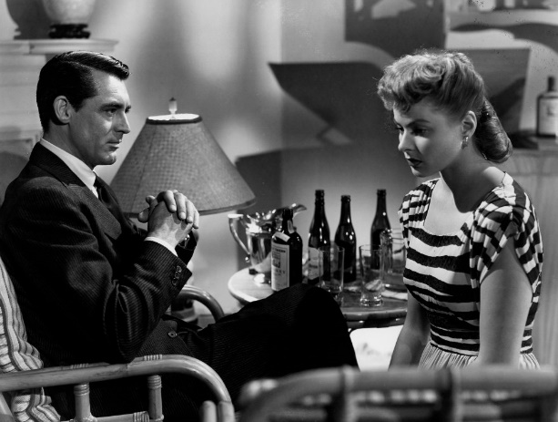
The site consists of a random elliptical series before Devi-night Alicia's meetings. In an upstream passage is a little table with a decorative vase (Ding, 2020). The clothes are open, and the cloth is weak. Contacts exist with his grandma at 6.40 a.m. The curtain is in danger of blindness while the movements are halfway.
We dissolve a 180-degree gadget in the shot called the first broad editing process. Alicia, the state of the axis continues (Magliano et al., (2020). Hitchcock is in the right direction to create a 3-door railway apartment to make its facilities effective. These doors are used in three bedrooms with an axis monitor and a bathroom party.
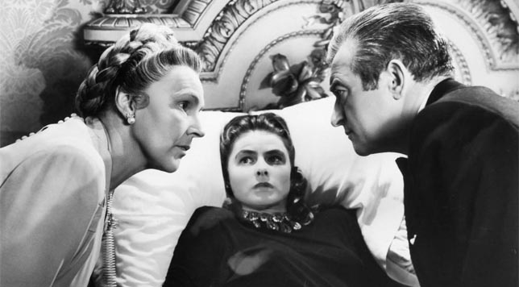
Alicia leads her to the heart of Alicia on one side and from her first wedding. The 180° Interface identifies and preserves Mise-en-Szenes' central location with the wine key and the markers around the primary key. Opium duplicity is expressed together in the treatment and resurrection of another soul as a core subject and a valid attribute of your companion. The machine shouldn't stop: never touch the motion axis, and the camera is sent to the city's action centers. Alicia takes the shadows and turns the Hitchcock from the core in the bathroom after her wife. The 180° law strengthens character and conduct but maintains the plot.
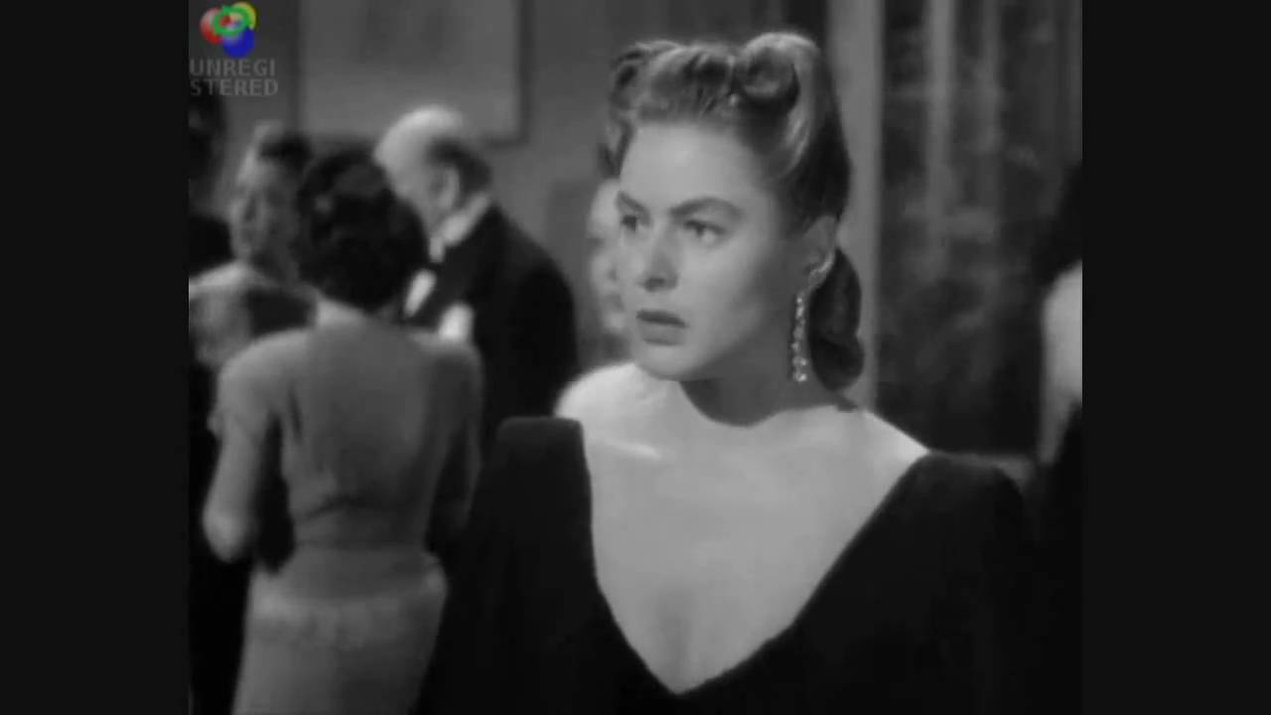
The second approach is to increase accuracy by rhythmic hacking to make the first Hitchcock simpler to drive. Scenes such as Alicia and her husband's bathroom are the crown of long pictures and dresses. Alicia's cellar displacement theory enhances the rhythmic cuts in Hitchcock. It changed from the image of Alicia to the next toilet. Alicia and her friends use the cat and the mouse paced. This axis causes fire variations but is connected to an RPM suspension. She's got fiber, and the wife of Alicia doesn't worry. The screen displays the axis.
However, this conference raises concerns regarding the avoidance of nationality. The intelligent use of the rhythm-driven version with an axis generates a fearful feeling and momentum, which shows the new film's precariousness.

Reference
Bruckert, A., Christie, M., & Meur, O. L. (2021). Where to look at the movies: Analyzing visual attention to understand movie editing. arXiv preprint arXiv:2102.13378.
Ding, Q. (2020, September). Analysis of Montage Application in Modern Stream of Consciousness Movie Editing. In 4th International Conference on Art Studies: Science, Experience, Education (ICASSEE 2020) (pp. 495-498). Atlantis Press.
Magliano, J. P., Kurby, C. A., Ackerman, T., Garlitch, S. M., & Stewart, J. M. (2020). Lights, camera, action: the role of editing and framing on the processing of filmed events. Journal of Cognitive Psychology, 32(5-6), 506-525.

